**EXPERIMENT NO. 10**

**AIM**: To make an air tight bottle cap by using injection moulding.

**EQUIPMENT** : Injection moulding machine.

**MATERIALS REQUIRED** : Plastic pellets.

**THEORY**: Plastics: Polymers can be divided into three broad divisions: plastics, fibers and elastomers (polymers of high elasticity, for example, rubber). Synthetic resins are usually referred to as plastics. Plastics derive their name from the fact that in a certain phase of their manufacture they are present in a plastic stage (that is acquire plasticity), which makes it possible to impart any desired shape to the product. Plastics fall into a category known chemically as high polymers. Thus Plastics is a term applied to compositions consisting of a mixture of high molecular compounds (synthetic polymers) and fillers, plasticizers, stains and pigments, lubricating and other substances. Some of the plastics contain nothing but resin (for instance, polyethylene, polystyrene).

**Types of Plastics**: Plastics are classified on the broad basis of whether heat causes them to set( thermosetting) or causes them to soften and melt(thermoplastic).

**Thermosetting Plastics:** These plastics undergo a number of chemical changes onheating and cure to infusible and practically insoluble articles. The chemical change is not reversible. Thermosetting plastics do not soften on reheating and cannot be reworked. They rather become harder due to completion of any left over polymerization reaction. Eventually at high temperatures, the useful properties of the plastics get destroyed. This is called degradation. The commonest thermosetting plastics are: alkyds, epoxides, melamines, polyesters, phenolics and ureas.

**Thermoplastic Plastics:** These plastics soften under heat, harden on cooling, and can beresoftened under heat. Thus they retain their fusibility, solubility and capability of being repeatedly shaped. The mechanical properties of these plastics are rather sensitive to temperature and to sunlight and exposure to temperature may cause thermal degradation.

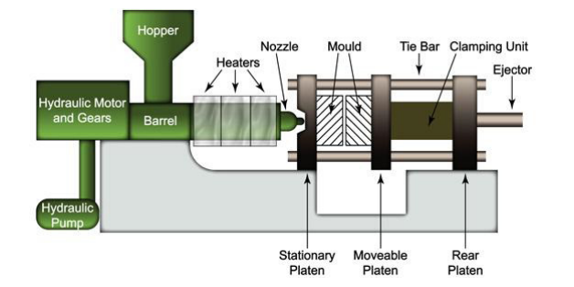

Common thermoplastics are: acrylics, poly tetra fluoro ethylene (PTFE), polyvinyl chlorides (PVC), nylons, polyethylene, polypropylene etc. Injection Moulding: An important industrial method of producing articles of thermoplastics is Injection Mouilding (shown in fig.).

The process is essentially as follows

The moulding material is loaded into a hopper from which it is transferred to a heating section by a feeding device, where the temperature is raised to 1500C – 3700C and pressure is built up. The material melts and is forced by an injection ram at high pressure through a nozzle and sprue into a closed mould which forms the part. The mould is in at least two sections, so that it may be split in order to eject the finished component. For the process to be competitive the mould must be fairly cool (between ambient temperature and the softening point of the plastic) and consequently the mould must be cooled by circulating air.

**PROCEDURE:** Injection moulding makes use of heat softening characteristics of thermo plastic materials. These materials soften when heated and re hardens when cooled. No chemical change takes place when the material is heated or cool. For this reason the softening and re hardening cycle can be repeated any no. of times.

1. The pellet form of plastic is introduced into the container through hopper.

2. The plastic pellet enters into the container. The container is heated with the coil, which is wounded around it.

3. The plastic of powder form is converted into molten stage at a temperature of 800C.

4. The die is placed exactly below the nozzle of the container.

5. The melted plastic is injected into the die with the help of lever arm and it is allowed to solidify say for about one minute.

6. Then retract the lever arm slightly and open the mould.

7. Then eject the mould piece of the required shape from the die.

**PRECAUTIONS:**

1. The material should not be heated rapidly.

2. The die should be placed exactly below the nozzle.

3. Proper temperature should be maintained while heating the plastic.

**RESULT:** Air tight bottle cap is prepared by using injection moulding